**MODULE 1:**

**SE – Overview of IT Industry**

1. What is software? What is software engineering?

ANS. Software is considered to be collection of executable programming code, associated libraries and documentations. Software, when made for a specific requirement is called software product. Engineering on the other hand, is all about developing products, using well-defined, scientific principles and methods.

1. Explain types of software ?

ANS. The two main categories of software are application software and system software. An application is software that fulfills a specific need or performs tasks. System software is designed to run a computer's hardware and provides a platform for applications to run on top of.

1. What is SDLC? Explain each phase of SDLC.

ANS. SDLC is a **Software Development Life Cycle. The Software Development Life Cycle (SDLC)**is a process used by software development organizations to plan, design, develop, test, deploy, and maintain software applications.

1. What is DFD? Create a DFD diagram on Flipkart.

ANS. **Data Flow Diagram ( DFD)** are visual maps that provides a clear understanding of how information moves within a information system.

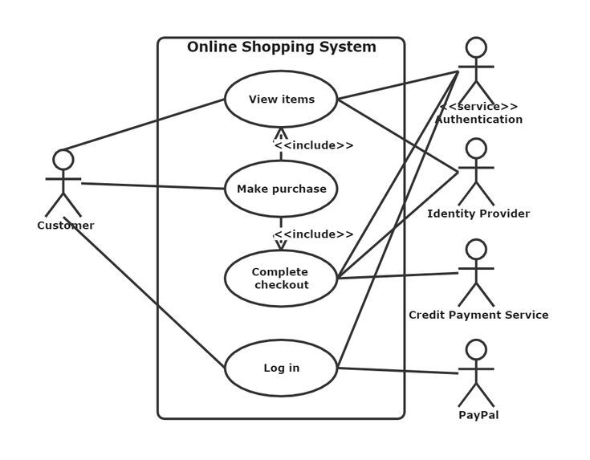

1. What is Flow chart? Create a flowchart to make addition of two numbers

ANS. A flowchart is a diagram that illustrates the steps, sequences, and decisions of a process or workflow.

Flow chart for Addition Number

Input Values

Add=No.1+No.2

Answer

6.What is Use case Diagram? Create a use-case on bill payment on paytm.

ANS. A use case diagram is a graphical depiction of a user's possible interactions with a system. A use case diagram shows various use cases and different types of users the system has and will often be accompanied by other types of diagrams as well.

